**Final Project**

1. Describe the Trauma Center simulation model's main processes, (for each process group) describe the process flow, i.e. where the patients arrive, go to next and so on (conditions for routing and parameters), resource types and levels, arrival rates, process durations, schedules. Also provide detailed response to the following questions:

* Explain the processing of the patients coming with Ambulance but not Triaged (i.e. bedside registration), i.e. how the nurse and EMS resources are interacting.
* Explain how PortableXRayByTech is modeled and how is it different than the standard X-Ray process.
* Explain the repetition of the Doctor examination through the code "AnotherCycleProb( agent.severity )" in Final review by Doctor

**Patients arrival. If walk in, triage and registration**

At the beginning of the simulation model, all patients arrive through the *Arrivals* source node, with a rate schedule defined by an arrival rate table that was imported and contains data about the Trauma Center’s daily workload.

These patients can come by walking in or by ambulance, with the *WalkIn* node selecting which source they came from. If they arrive by ambulance, a quick triage is done to determine the severity of the trauma. The *TriageAfterAmb* node runs a probability, that can redirect the patient to usual triage (if its condition is not severe) or to the **ED process**. If the patient walks in normally, the usual triage is conducted every time.

The triage consists in a flow process, conducted by a single triage nurse, where the patient goes through it and is redirected to a waiting room afterwards. Its duration is a triangular distribution, with 1, 4 and 9 minutes being its parameters. Then, a registrar is seized (the responsible for conducting the registration process) and the patient is taken to registration, the maximum capacity for simultaneous registration is two. Its time is also a triangular distribution, with 4, 7.3 and 13 minutes. After, the patient goes back to the waiting room and the registrar is released for new patients.

**EC: Go to room, assessment and preparation**

After the registrar is released, an evaluation is conducted, based on patient’s condition, to analyze if the patient has to go to the EC room and if it is open. If not, the patient goes directly to the **ED process** (in more severe cases).

When a patient has to go to an EC room, first we check for room availability, to allocate a room for him/her. There are a total of 8 different rooms available for our express care (EC). Then, our next process is checking the availability of a nurse. When our room and the nurse are ready, the nurse takes the patient to the room and goes away.

Afterwards, we set a tech assistant and PA (physical assistant) for the process. Both come to the room and record the details about the patient. After the PA is done with collecting information, the tech assistant is released and the patient goes for the **X-Ray** process. For the initial evaluation time period, the time it takes is a triangular distribution with 5, 9 and 18 minutes.

**EC: X-Ray**

After the tech responsible is released, an analysis is made to determine if the patient needs an X-Ray or not, through the *XRayNeeded* node. If not, the patient is redirected directly into the **Treat and Discharge** process; if it is, the physician assistant is going to do the initial examination on the patient. This examination also takes a triangular distribution of time, with 5, 7 and 10 minutes as parameters.

Afterwards, the physician assistant is released and a X-Ray room is seized, between the two available, together with one of the two X-Ray techs. The patient is then conducted to the room and the X-Ray is done, with a process time of a triangular distribution that has 15, 20 and 30 minutes as parameters.

The patient is then brought back to the EC room and waits for the X-Ray results (triangular distribution with 7, 10 and 20 minutes). After the results are done, both the X-Ray room and the X-Ray tech are released, becoming available for the next patient, and one of the five doctors is responsible for reviewing those (triangular distribution with 3, 5 and 7 minutes).

Again, the physician assistant is seized and the patient is redirected to the **Treat and Discharge** process.

**EC: Treat and discharge**

This process is two fold. First, an analysis is conducted to see if there is a need for a specialist to exam the patient. When a specialist treats a patient it usually takes 8 to 18 minutes, with the average time being 13 minutes. There are two available specialists for executing this task.

If the condition does not need a specialist treatment, the seized PA takes care of the patient. In this case, the duration time for each patient is 10 to 30 minutes, with the average being 15 minutes. Usually PA takes a longer time to see a patient than a specialist.

After these procedures, the patient is ready for discharge from express care. The waiting time for the discharge process has an average of 5 minutes, minimum 3 and maximum 7 minutes. Upon conclusion, the physician assistant is released and an available nurse is allocated to help the patient.

In the meantime, the room is ready for new patients, and the nurse shows the direction of the exit to the person who was being treated on express care. After, the nurse is released and the patient exits the Trauma Center (through the *DischargedEC* sink node).

**Start of ED process (bedside registration if by EMS)**

As said before, the patients can come to the ED process in two different ways. First, they can come directly from the ambulance, in their initial arrival at the Trauma Center, if their condition is severe. In that case, one of the fifteen ED rooms is seized, together with one of the six available nurses.

In this scenario, an individual nurse has its own routine, where it is assigned to a specific EMS (emergency medical service). When the need for an EMS appears, the nurse has to walk to the patient and guide them to the ED room. After getting there, the EMS is completed and the nurse has to go back to its original position, since its job of getting the patient to the ED room was finished. Upon this, the EMS is freed and the nurse’s task is completed.

At the ED room, a bedside registration is done by a registrar (triangular distribution with 6, 9 and 15 minutes) and after it finished, the **Preparation and initial treatment** process begins.

Alternatively, the patients can come to the ED process after the initial registration, when they check if the patient should go to the EC room or to the ED one (depending on its condition). In this case, the process is similar, allocating an ED room and a nurse that is responsible for conducting the patient to the room and released afterwards. Since the registration was already made, there is no need for a bedside registration, and the **Preparation and initial treatment** process begins.

**Preparation and initial treatment**

This process gets patients from two different sources. First, they can come from the **Start of ED process**, after a nurse releases them or the bedside registration finishes, or they can come from the **Final review by Doctor**, if the doctor judges that the patient needs further treatment.

In this process a room has to be prepared by a tech assistant and a nurse, to be available for patients. It takes usually 3 to 15 minutes to clean the room in between every service. Then the patient is ready to get service at the ED room. Then, a doctor is assigned and execute its job. The service time of a doctor for each patient varies from person to person. A doctor usually spends on average 8 minutes with each patient. If the situation demand the highest amount of time, it takes 15 minutes, otherwise minimum time is 2 minutes.

After the initial observation, based on doctor prescription, a patient has to go through either a specialist or directly to the order processing (where requests for X-Ray and other additional exams are made). Then, if they have to go through a specialist, one of them should be allocated to it. Since the specialist are experts in their field, the patient has a chance to get the best treatment. During the ED room specialist checkup, the amount of time spent is longer (maximum time 30 minutes, minimum time 5 minutes, and average 10 minutes).

When the treatments are over, a order is processed to check if the patient needs further exams. To process all the order, it usually takes from 2 to 15 minutes, on average it is 8 minutes. Then, the specialist is released and gets ready for the next patient in the queue, while a analysis is made to see if the patient needs to go through a laboratory test.

For the patient for whom laboratory work is required, they do the necessary tests and wait for its results. The waiting time for varies from test to test, taking more than five hours in some cases. There are also some test results which are possible to get within 10 minutes. Next, the patient enters the **X-Ray** process.

**X-Ray**

The patients come for the X-Ray process by two different paths, both of them from the **Preparation and initial treatment** process. Either the patients are submitted to the laboratory exams and get there after they got its results, or they do not have the need for these exams, and go directly to the X-Ray process.

At the beginning of the X-Ray process, the patients are evaluated if they do have the need for this procedure. If not, the patient is guided to the **CAT/VQ/US** process; otherwise, if there is a need for X-Ray, an analysis is made to see if it is necessary to use the portable X-Ray or the usual one.

In the portable X-Ray case, the procedure is done without the need for assigning a X-Ray room or tech, and it takes a triangular distribution time, with 15, 20 and 60 minutes as parameters. If there is a need for a X-Ray room, one of the two rooms is allocated, together with a X-Ray technician and the patient is guided to that room. The procedure is also a triangular distribution, with 15, 20 and 30 minutes as parameters, and after that the patient goes back to the ED room to wait for the results (triangular distribution with 7, 10 and 20 minutes).

After the results are complete, the X-Ray room and technician are released, and the patient goes to the **CAT/VQ/US** process.

**CAT / VQ / US**

The patient in this process can come from two previous stages, either from the beginning of the **X-Ray** process, where there is no need to execute a X-Ray, or from the end, after the X-Ray is conducted.

In every different test, an analysis is made to determine if the patient needs that specific procedure or not. If the conclusion is negative, the patient just jumps for the next procedure’s analysis.

At the CAT Scan process, the patient needs to take a special medicine and wait a specific amount of time so the medicine can take action (the distribution is triangle shaped, with maximum of 120, mean of 20 and minimum of 10 minutes). The CAT Scan execution time is 2 to 95 minutes.

At the VQ Scan case, the patient can come from two different paths: people who already did their CAT Scan or after doing their X-Ray. The duration time of doing VQ Scan is exactly the same distribution to the CAT Scan.

Finally, the ultrasound is another test in which some patients are prescribed to do, and some don’t. Those who do not need to do it will directly go to the **Final review by Doctor**, the others should wait for the test; the total time for doing the test is 35 to 90 minutes. After all the test is done, that patient will follow to the **Final review by Doctor**.

**Final review by Doctor**

After the evaluations for CAT/VQ scans and the ultrasound, the results are analyzed by a doctor. For this, one of the five available doctors is seized and realizes the review of each document (triangular distribution with 3, 5 and 7 minutes). Then, there are two possible outcomes: the doctor can conclude that the patient needs further treatment (evaluation in the *AnotherCycle* node), in which case the doctor is released and the patient goes back to the **Preparation and initial treatment** process; or the patient is either admitted or discharged.

In the second outcome, the process for admission or discharging take time (triangular distribution with 3, 5 and 7 minutes) and then the doctor is released, guiding each patient into one of both processes.

**Admit**

If the patient is redirected to the admit process, a nurse is seized to conduct the process. The nurse has its own flow chart, where before getting attached to the task he/she has to pick up an allocated transport and go to the location where the patient is.

After getting there, the process of admission begins, with a triangular distribution duration of 3, 5 and 7 minutes. Then, the ED room is released and the patient is conducted to the exit by the nurse, getting out of the Trauma Center by the *Admitter* sink node.

After the nurse is released, she takes the transport back to its original location, and release its allocation so it can be free for the next patient. Then, her work with this specific patient is finished.

**Discharge**

When arriving at the discharge process, a nurse is allocated to be responsible for the final discharge process and guiding the patient to the Trauma Center’s exit. The discharge process takes a triangular distribution time, with 3, 5 and 7 minutes.

After that, the ED room is released and the patient goes to the exit together with the nurse, which is later released as well. Finally, the patient exits the Trauma Center, through the *DischargedED* sink node.

1. **(10 points)** Run the simulation model for a week (7 days) and report on
   * Length of Stay for EC and ED
   * Utilization of Doctors, Specialists, PA, Nurse, Triage Nurse, Registrar, xRay Tech
   * Utilization of EC, ED, BCU, XRAY

To run the simulation model for a week, in the simulation panel we access the Developer panel and enabled the advanced options. There, we inserted an entry for seven days, and clicked in the “Run for a given time interval, then pause” option.

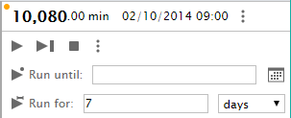

Figure 1: Panel configuration for running through 7 days.

After the simulation ended, we could find the desired information in each different tab. From the “Statistics” tab, the following data regarding length of stay for EC and ED was available.

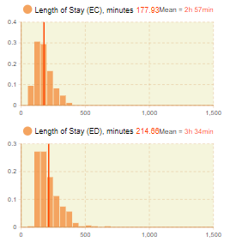

Figure 2: Statistics related to length of stay for EC and ED.

As we can notice, the average length of stay in EC is 2h57min, while the one for ED is 3h34min. This difference was expected, since the patients who are taken to ED rooms have a more severe condition and sometimes need to be examined by more than one person (a doctor and a specialist, for example). Also, in the case where patients go to ED rooms, there is a possibility that the doctor asks for another cycle of treatment, which can increase considerably the time spent in these rooms. Finally, in the case where patients go from the ambulance directly to the ED room, a bedside registration is conducted, which also takes time and prolong the average stay.

For the employees, still looking at the “Statistics” tab, we have different progress bar charts that shows its level of utilization (figure 3).

As we can see, the two most allocated employees were the nurses, with 52% of usage, and the specialists, with 46% of usage. Also, the registrars are close to these numbers, with a total of 44% of usage. These are the top three priorities for spending resources directed towards employees, if needed, in order to make the processes more efficient.

Alternatively, the CATTech, together with the UTech, are the employees with the least amount of usage, with 4% and 3%, respectively, followed by the Triage Nurse with 17%. Since all of these have only one employee, there is no need for lowering the spending in these resources.

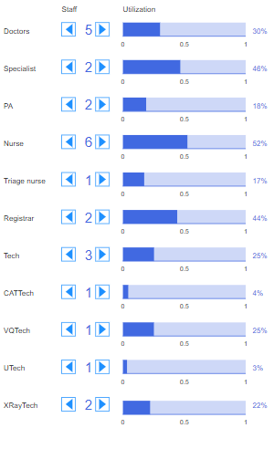

Figure 3: Information about usage of each type of employee during the simulation.

Finally, in the “Statistics” tab, we can also give a look in the usage of each type of room, shown in the figure 4.

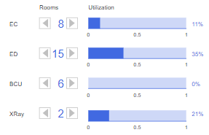

Figure 4: Information about usage of each type of room during the simulation.

Looking into the graphs, it is clear that the ED room is the one with most usage amount; even with 15 rooms, its usage is still around 35%. This is justified by the high average time spent by patients in these rooms, which we noticed to be around 3h34min. Investing in more ED rooms could be suitable for this trauma center, but speeding up the average time can also be a possible solution.

At the other side, the BCU are the rooms with the least usage time, with 0%. Turning these rooms into ED rooms could be a good task, since there are 6 different spaces allocated for this activity that are not being intensively used throughout the simulation.

1. **(10 points)** What is the minimum number of Doctors and Nurses to obtain >=80% utilization for each of these (change the level of Doctor and Nurse resources one at a time)? Does changing one resource (nurse or doctor) affect the utilization of the other

For this question, we ran the simulation for the seven days and analyzed the utilization levels for doctors and nurses. In each scenario, we ran the entire process three times because there is some uncertainty due to the probabilities that involves both EC and ED sections (based on patient condition, each one is allocated to a specific section, and this can change the amount of usage of each agent). Finally, we collected average values of those three runs. It is worth mentioned here that we checked both doctor and nurse utilizations by changing one variable and changing another one. For example, when we change the no of doctors we keep no of nurse constant and vice versa.

Table 1. Utilization of doctors and nurses with the variation of no of doctors while keeping no of nurses constant.

|  |  |  |  |  |  |  |  |  |  |
| --- | --- | --- | --- | --- | --- | --- | --- | --- | --- |
| # of Doctor | # of Nurse | Utilization of Doctors (%) | | | | Utilization of Nurse (%) | | | |
| 1st run | 2nd run | 3rd run | Average | 1st run | 2nd run | 3rd run | Average |
| 1 | 5 | 99 | 99 | 99 | 99 | 44 | 44 | 44 | 44 |
| 2 | 5 | 84 | 80 | 83 | 82.3 | 67 | 66 | 70 | 67.7 |
| 3 | 5 | 52 | 58 | 55 | 55 | 70 | 73 | 69 | 70.7 |
| 4 | 5 | 38 | 39 | 41 | 39.3 | 69 | 67 | 69 | 68.3 |

The table 1 shows the percentage of utilization of both doctors and nurses with the change of no of doctors while keeping the no of nurses constant. As shown in table 1, the average utilization rate of doctors reduces with the increase of no of doctors. When the no of doctors are one and two, the utilization is more than 80%. On the other hand, the utilization of nurse increases with the increase of no of doctors until no of doctors are three and then reduce with further increase of doctor to four. However, the nurse utilization does not meet our minimum criteria. Therefore, we need to run another set of simulations by changing the nof of nurse. It is worth mentioned here that the no of nurse is constant 5.

Table 2. Utilization of doctors and nurses with the variation of no of nurses while keeping no of doctors constant.

|  |  |  |  |  |  |  |  |  |  |
| --- | --- | --- | --- | --- | --- | --- | --- | --- | --- |
| # of Doctor | # of Nurse | Utilization of Doctors (%) | | | | Utilization of Nurse (%) | | | |
| 1st run | 2nd run | 3rd run | Average | 1st run | 2nd run | 3rd run | Average |
| 2 | 1 | 19 | 20 | 20 | 19.7 | 99 | 99 | 99 | 99 |
| 2 | 2 | 46 | 46 | 46 | 46 | 99 | 99 | 99 | 99 |
| 2 | 3 | 70 | 68 | 71 | 69.7 | 99 | 99 | 99 | 99 |
| 2 | 4 | 90 | 85 | 75 | 83.3 | 89 | 87 | 76 | 84 |

The utilization of doctors is the highest, i.e. 99 when there are one doctors and we tend to avoid this configuration because doctors will be very busy all the time. If the doctor is not available for some unwanted reasons, the patients will not get emergency services.Thus, we selected our second set where the no of doctors are two and it meets our minimum criteria mentioned in the question.

The table 2 shows the percentage of utilization of both doctors and nurses with the change of no of nurses while keeping the no of doctors constant. As shown in table 2, the utilization increases with the increase of no of nurses but the utilization of nurse remains constant until no of nurses are three and drops further when the no of nurses are four. Based on the results shown in table 2, the minimum utilization criteria of 80% or more is met when there are two doctors and four nurses.

1. **(10 points)** (independent of other modifications) EC currently runs from 11am to 19pm for 8 hours. Explore the effect of running EC longer (10 hours 10am till 20pm) and shorter (6 hours 12 till 18pm) on the statistics (asked in #2 above)

To alter the working hours of the Trauma Center, we can modify its properties at the “Simulation: Main” tab, going into the “Working hours” options, as shown in the figure 5.

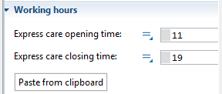

Figure 5: Working hours properties inside the simulation tab.

For the initial simulation, we ran the EC during 8 hours (from 11am to 7pm), and got a average length of stay of 2h57min, together with an utilization of 11%. Since during our previous analysis we have noticed that probability has a lot of influence in simulation times, in this exercise we are going to execute each model several times, so we can look into average values and try to lower uncertainty.

|  |  |  |  |  |  |
| --- | --- | --- | --- | --- | --- |
| Simulation | 1st run | 2nd run | 3rd run | 4th run | Average |
| 11am to 7pm | 2h57min | 3h01min | 3h04min | 3h15min | 3h04min |
| 10am to 8pm | 3h06min | 2h59min | 3h13min | 3h35min | 3h13min |
| 12pm to 6pm | 3h15min | 3h21min | 3h27min | 3h49min | 3h28min |

Simulation values for average length of stay in each run.

|  |  |  |  |  |  |
| --- | --- | --- | --- | --- | --- |
| Simulation | 1st run | 2nd run | 3rd run | 4th run | Average |
| 11am to 7pm | 11% | 11% | 9% | 13% | 11% |
| 10am to 8pm | 11% | 13% | 15% | 15% | 13.5% |
| 12pm to 6pm | 8% | 9% | 10% | 14% | 10.25% |

Simulation values for utilization in each run.

As we can see, there was not a great change in the average length of stay for the EC rooms. These values are deeply influenced by the probabilities present in the model, and change constantly between every simulation. Although we did not see any pattern in the time, it is possible to see an increase of utilization when the Trauma Center is working for more hours, and a decrease when is working for less hours. Even so, these changes are not big, representing a change of 3% at maximum.

**B.** **(100 points)** Modify (use the logic and components if needed) the Trauma Center simulation to create a simple Outpatient Center model described in the following portion of the project and respond to the questions.

a) **(60 points)** Build and run a simulation of 30 round-the-clock 24-hour days and observe/report the average total time in system of patients, the average number of patients present in the clinic, as well as the throughput of the clinic (number of patients who leave the clinic and go home over the 30 days); also make a plot of the number of patients present in the clinic, and display a throughput counter. If you could afford to add resources, where is the need most pressing?

For this exercise, the following model was built according to the instructions given by the document, explaining the Outpatient Center operating tasks (for a better visualization, please look at the attached file).

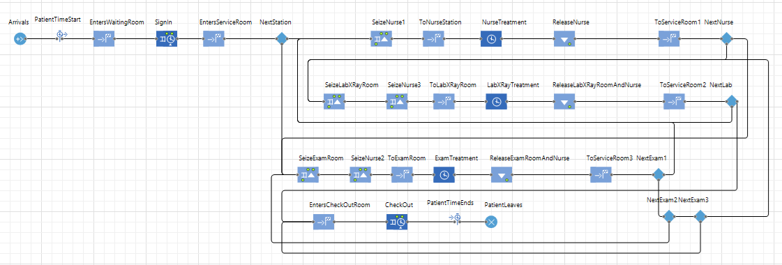

Figure 6: Built model for the Outpatient Center.

Then, a simulation was executed for the whole 30 round-the-clock 24-hour days. Since there was no specification in the instructions about the initial number of nurses, we made an assumption of 5.

To gather the average total time in system for patient, we inserted a TimeMeasureStart node, at the moment when the patient enters the center, and a TimeMeasureEnd at the time when he leaves it.

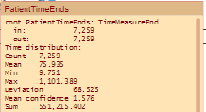

Figure 7: TimeMeasureEnd statistics about average time spent by each patient.

As we can see, the average time spent by each patient is 76 minutes, with the minimum time being 9 minutes and the maximum 1,101 minutes. Through the simulation, we can also see the patient throughput, looking at the sink node, and get the total amount of patients that left the clinic in those 30 days.



Figure 8: Check-out process for the simulated model.

At the PatientLeaves sink node, we can see that 7,259 patients attended the Outpatient Center in those 30 days. For the average number of patients in the clinic, we couldn’t find a specific function in AnyLogic to compute that information, but we can divide the total amount of patients (7,259) by the number of minutes in the simulation (43,200), to discover the average number of patients per minute (0.168). Since the average time spent for each patient is 76 minutes, we can multiply this quantity by the number of patients per minute (0.168) to get the average number of patients in the clinic: 12.77.

During our simulation, we tried to insert the plots to show the current number of patients in the clinic, as well as the statistic about the throughput of patients, but we could not find the necessary method for the Patient’s Agent (Patient.method()) that is responsible for counting its values. We understand which tools should be used for plotting the information (Bar Chart and Statistics at the Analysis tab), but AnyLogic’s documentation does not contain clear instructions on how to do it (and the Trauma Center’s example only uses the Doctor.utilization() function to get utilization values, not count values).

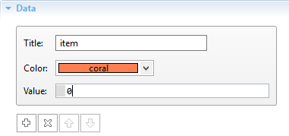

Figure 9: Value field where Patient.method() should be inserted to display the data into a Bar Chart.

Finally, when running the simulation, we noticed that the utilization percentages for the exam rooms are the highest, reaching 91%. Thus, if we could add resources into the Outpatient Center, another exam room would be the best option (considering our initial number of nurses with 5). If the initial number of nurses is lower, its utilization can climb up to 99%, where adding resources in hiring other nurses would be better.

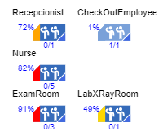

Figure 10: Utilization for each resource pool in the simulation.

b) **(20 points)** In the outpatient clinic above, suppose you could add one unit of resource to any one of the five stations (receptionist, nurse, exam room, checkout administrator, or lab technician). Where would be the most useful addition? Look at both average patient total time in system, as well as patient throughput.

The most useful addition of resources would be another exam room. Its utilization percentage is significantly higher than the nurses (9% more) and it has a higher time distribution than the nurse treatment at the nurse’s station.

Even though nurses are more demanded, because they need to guide each patient through all exams, the exam room provides a limitation for the nurses, since only three of them can use it simultaneously. Besides, looking at the patient throughput in the exam rooms, we can see that it was used 14,451 times, meaning that each patient uses this room roughly 2 times, which also shows that this resource is also highly demanded.

c) (**20 points**) The outpatient clinic has received an economic-stimulus capital grant of $400,000 to expand service and reduce patients’ average total time in system. They can allocate these funds in any way they like to add any number of resources to any of the five stations, though they cannot reduce any resources below current levels (one at each station, except three exam rooms). The clinic has the following capital-costs estimates for an additional unit of resource at each station; also given are the maximum number additional resources to each station if the entire $400,000 were allocated to that station:

• Receptionist $40,000 could add max of 10

• Nurse $80,000 could add max of 5

• Exam Room $200,000 could add max of 2

• Lab/X-Ray $100,000 could add max of 4

• Check Out $50,000 could add max of 8

As the problem states, we need to have at least one item at each station except exam room. This means we cannot add a single exam room because we won’t be able to have at least one item under each five station. Therefore, the only combination we can have is shown in table 1 assuming the total price has to be maintained within $400k.

Table 3. Combinations of five items for $400k fund utilization.

|  |  |  |  |  |  |  |
| --- | --- | --- | --- | --- | --- | --- |
|  | Receptionist  ($40k) | Nurse  ($80k) | Exam room  ($200k) | Lab/X-ray  ($100k) | Check out ($50k) | Total money utilized ($S) |
| No of Items | 1 | 2 | 0 | 1 | 2 | 400,000 |
| Utilization (%) | 73 | 99 | 99 | 80 | 0 | 400,000 |

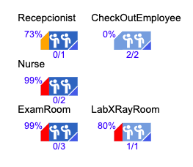

Figure 11: Utilization for each resource pool in the simulation.

As shown in figure 11, the utilization of receptionist is low, i.e. 73%. The check out employee has not been utilized at all. This means that check out employees are not required. However, we have to add at least one check out employee according to our given conditions. Nurse is fully utilized, 99%. This means nurses won’t have time to rest and if no of available nurses drops on any day due to unwanted reasons, the patient would be in dangerous situations. Similarly, exam room is 99% utilized and we have not invested any money for exam room due to shortage of fund. The utilization of Lab X-ray room is in the higher end, i.e. 80%. Even though we need to add exam room, more nurses, and Lab X-ray room, we cannot do that due to shortage of funding. Similarly, we cannot go beyond threshold of receptionist and check out employee. Therefore, there is no further combination of $400k fund utilization.

This analysis infers that the clinic requires more funding in order to provide best services to the patients.